Question – 1 Write a function to find the greatest number from the given array of any size. (TSRS).

Ans.

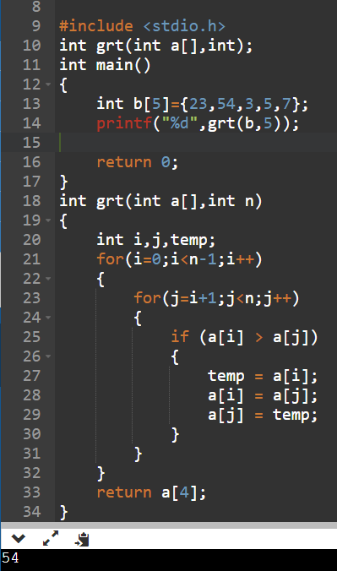

Question – 2 Write a function to find the smallest number from the given array of any size. (TSRS).

Ans.

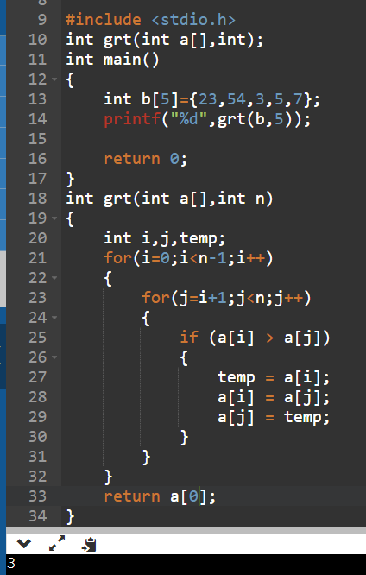

Question – 3 Write a function to sort an array of any size. (TSRS)

Ans.

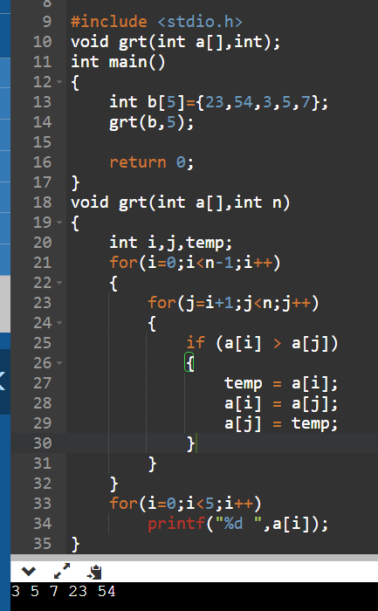

Question – 4 Write a function to rotate an array by n position in d direction. The d is an indicative

value for left or right. (For example, if array of size 5 is [32, 29, 40, 12, 70]; n is 2 and

d is left, then the resulting array after left rotation 2 times is [40, 12, 70, 32, 29] )

Ans.

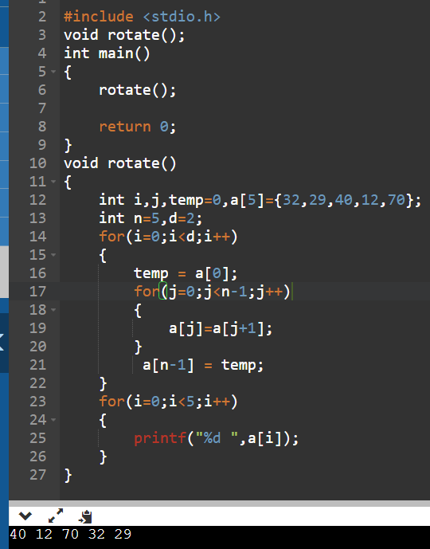

Question – 5 Write a function to find the first occurrence of adjacent duplicate values in the array.

Ans.

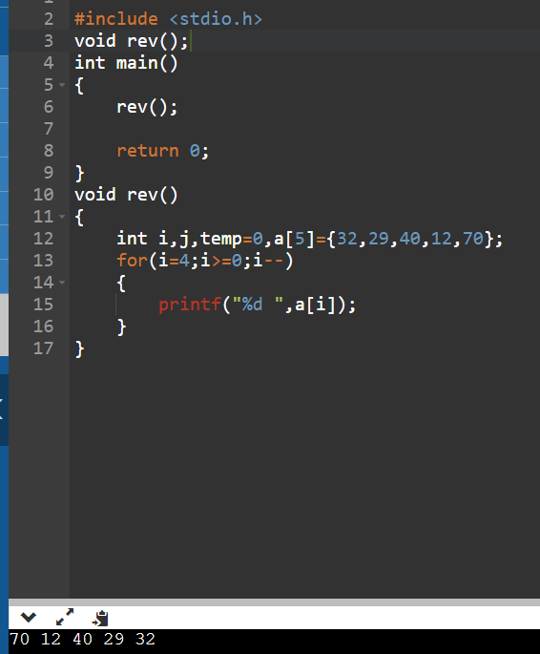

Question – 6 Write a function in C to read n number of values in an array and display it in reverse order.

Ans.



Question – 7 Write a function in C to count a total number of duplicate elements in an array.

Ans.

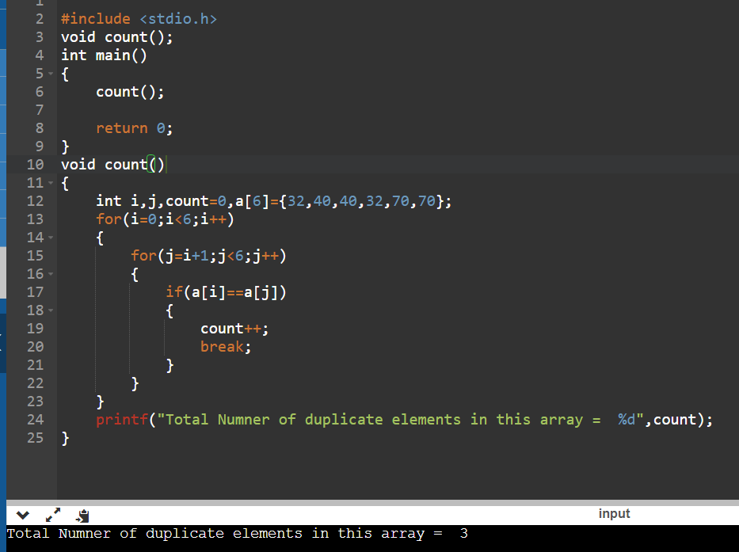

Question – 8 Write a function in C to print all unique elements in an array.

Ans.

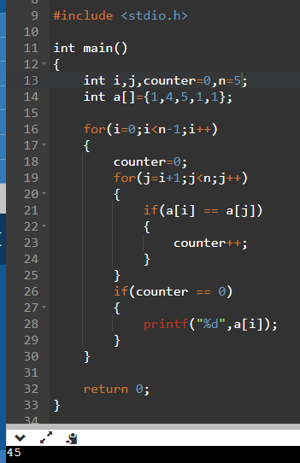

Question – 9 Write a function in C to merge two arrays of the same size sorted in descending

order.

Ans.

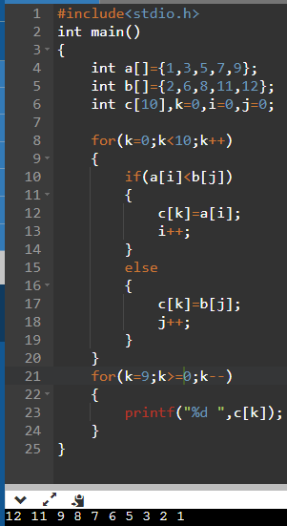

Question – 10 Write a function in C to count the frequency of each element of an array..

Ans.

